Gran March
As of the Year 587 CY.
Some of the information here was taken from LGG, Canonfire forums and Living Greyhawk material.
http://www.greyhawkonline.com/granmarch/public_lib/pages/heraldry.htm

Table of Contents
Gran March 1
Outline 3
History 4
Maps 6
People of the Gran March 10
Baronies of Gran March 13
Barony of Paysanne 13
Barony of Shiboleth 13
Barony of Glynwych 13
Barony of Hethiye 13
Barony of MacAoidh 13
Barony of Muraille 14
Barony of Valonn 14
Barony of Collinae 14
Barony of Holiford 14
Barony of Harnarchus 14
Domain of the Rushmoors 14
Domain of the Dim forest 15
Protectorate of Hochoch 15
The Army 16
The Equality of Might edict 16
Mustering day 16
Army breakdown 17
Life in the army 18
Awards 19
Pensions 19
Reserves 19
Relationships 20
Noble house of the Gran March 21
House Nehelin (Major house) 22
House Rholgran (Major house) 23
House Dorh (Major house) 25
House Heth (Major house) 26
House Aoidthane (Major house) 27
House Harc (Major house) 28
House Murthane (Major house) 29
House Valon (Major house) 30
House Collinae (Major house) 31
House Holithane (Major house) 32
House Dassas (Minor house) 33
House Wolsing (Minor house) 34
House Souldthane (Minor house) 35
House Prouse (Minor house) 36
House Stren (Minor house) 37
Flavor 38
A Knightly Society 38
The Gran March Comes of Age 38
Keoland and the March 38
Internal Politics within the Gran March 38
External Politics 38
The Laws and Institutions of Gran March 40
Law and Order 40
The Laws and Institutions of Gran March 41
Year 595 CY 43

Outline
Proper Name: Gran March
Ruler: His Most Resolute Magnitude, Magnus Vrianian, Commandant of Gran March (LG male human Wiz9 (evoker)/Clr3 of Heironeous)
Government: Feudal monarchy where the Commandant is chosen every five years by vote of nobles and knights; minor fealty to Keoland; overseeing current government in Bissel; noble houses and government are closely entwined with a militant quasi-religious knighthood, the Knights of the Watch;
Capital: Hookhill
Major Towns: Hookhill (pop. 7,500), Shiboleth (pop. 5,900)
Provinces: Ten great baronies, two marches (eastern Dim Forest, Rushmoors), captured territory (Hochoch; see text)
Resources: Foodstuffs, cloth, copper, gems (III)
Coinage: [Modified Keoland] griffon (pp), lion (gp), eagle (ep), white owl (sp), heron (cp)
Population: 254, 600-Human 79% (SOf), Elf 8% (sylvan), Dwarf 5%, Halfling 3%, Gnome 2%, Half-elf 1%, Half-orc 1%, Other 1%
Languages: Common, Keolandish, Elven, Dwarven
Alignments: LN*, LG, N
Religions: Heironeous, St. Cuthbert, Pholtus, Fharlanghn, Zilchus, Oeridian agricultural gods, Phyton, Obad-Hai
Allies: Keoland, Sterich, Bissel, Ulek states.
Enemies: Ket, nonhumans in Geoff and Crystalmists

The Gran March occupies the fertile plains east of the expansive Dim Forest and west of the Lortmil Mountains, bounded by the northernmost fork of the Sheldomar River in the south. A poorly defined "open" border marks the north, where nobles often kept court in both Bissel and Gran March.

These days, there seems to be little difference between the two governments, though the land within one day’s march (30 miles) north of Hookhill is considered part of Gran March proper. This territory also includes portions of Dim Forest and the Rushmoors, a haunted fen that has plagued the southern march for much of its long history.

The Gran March is almost wholly independent of Keoland now, and has been a surprising winner in the post-war days. This well-resourced land is now powerful despite its small size, and the words of its ambassador are carefully listened to in Keoland, Veluna, and Furyondy. If the Gran March has a lingering anger, it is concern over the fate of Bissel, with which it historically had warm relations.

The northern baronies enjoy a temperate, dry climate not unlike that found in Bissel. The south, however, is a land of dark mists and frequent showers, particularly near the forest and swamp. Gran March is an exceptionally martial nation. At age fifteen, all fit males enter mandatory conscription for a period of up to seven years. Girls may join the rank and file, as well, though this is something of a modern development, and their participation is not seen as mandatory (though several influential women in the military hierarchy believe it should be). It is a testament to the national pride of the nation's young people that many continue after their required service, and those who do not are generally members of local militias.

Internationally renown mailed cavalry forms the core of Gran March's impressive army. Armed with lances, crossbows, and swords, these riders are the bane of giants inhabiting Geoff. The Knights of the Watch and Knights of Dispatch offer support and welcome tactical expertise. The total standing army includes more than eighteen thousand soldiers. At least three times as many trained troops can be called up within a single week.

History
To truly understand the history of the Gran March one must look to distant past event in the Sheldomar Valley. Over a millennium ago, the whole of the Seldomar Valley formed part of what was then the empire of Vecna the lich lord. When Vecna was killed in the eleventh century BCY his empire gradually fractured. After this several small Flanae kingdoms arise, but none match the might of the tribe of Ur (known as the Ur-Flanae) under Vecna. Several northern Flan fearing both the wrath of the elves and the brutality of another lich-king flee their cities and turn back to a tribal system of government. This tribal system is what ruled the Sheldomar Valley for hundreds of years until the coming of the Suel at the end of the fifth century BCY. The Suel settling in Keoland, although a proud people, where refugees in the Flanaess and tired of war. As such, they used diplomacy and manipulation to forge Keoland with the native flan and demi-human tribes located there. When word came from explorers that the ancient enemy, the Bakluni, were spotted far to the north the Keoish king created an order of knights, the Knights of the March, to secure the northern passes. To ensure that the Knights of the Watch were dedicated in their zeal, it was formed entirely of those from Suel racial stock. The Knights were ordered to hold the pass near where Thornward is currently located and prevent any incursion of the Bakluni into the Flanaess.

Legend has it that the leader of the Knights took out a map and drew a straight line between Niole Dra and Thornward, selecting location for fortresses along that line. Two of those fortresses became the towns of Shiboleth, placed as a means of crossing the Seldomar river, as well as being on the edge of the Rushmoors to guard against any unwanted interference from that direction, and Hookhill as a trading post with the dwarven iron mines in the Lortmils. Between the two, at one day travel intervals, were placed small keeps. A primary roadway, known as the Watchtower Road, was eventually built linking all these keeps.

Once the path was laid out the Knights of the March had no interest in creating a new country or kingdom out of the Gran March. Their only interest lay in ensuring a secure and quick path from Keoland to Thornward and the Bakluni hordes beyond. This suited the various native Flan tribes, demi-human enclaves and various other factions just fine as they also had no desire to be joined in a unified kingdom. Thus, the patchwork for what was to become the Gran March was laid out; a central corridor controlled by the Knights of the March and the rest of the country controlled by various chieftains, thanes and speakers. Eventually the Keoish crown named the leader of the knighthood as commandant of Gran March, a title that carried with it control of the land between the Rushmoors and Lortmils.

Life in Gran March was peaceful and safe. Although there was some tension between the Knights of the Watch and the native rulers, the political landscape was mostly one of ambivalence; each faction doing what they wanted within their lands without much interference from the others. The Knight’s Road, bisecting the Gran March, became a corridor of trade for all the factions, with the keeps held by the Knights of the Watch as neutral ground trading posts. As trade grew over time, the Commandant’s rulership over the land became more substantial. With the Commandant controlling the most trained force in the land, few dared oppose him. When a perceived threat from within beset the nation, the Knights of the March sprung upon it fiercely and decisively. Sometimes, such reprisals came with little warning, often against seemingly upstanding members of the native rulers. The knights followed the secret teachings of their own inscrutable doctrine, and they showed no interest in explaining their actions to commoners.

The early 300s CY brought the Baklunish Brazen Horde to Ket, causing much consternation in the courts of the east and south. In order to protect his holdings against this Paynim threat, King Tavish I of Keoland ordered the foundation of the Knights of the Watch, built upon the basis of the Knights of the March and commanded by its leaders. This new, international knighthood quickly spread to Geoff, Bissel, and the heart of the empire, all the while retaining strong roots and key leadership in Gran March. Indeed, the commandant became titular ruler of the massive knighthood, as well as leader of his nation.

With the dawning of Keoland's wars of aggression, in 350 CY, Gran March gained international notoriety as the primary staging ground for the Second Expeditionary Army, which invaded Veluna from the southwest. After the success of that campaign, the capital of Hookhill became an important caravan stop to points north, which served to increase the wealth of the province.

By 415 CY, life in Gran March had grown extraordinarily difficult, thanks in part to Commandant Berlikyn, a harsh ruler who demanded nothing less than the most of his citizens-the most labor, the most money, the most effort. The king in distant Niole Dra knew nothing of Berlikyn's tactics, seeing only the impressive results. In appreciation, Tavish III appointed the commandant to be the supreme commander of all the northern provinces, which at the time included Gran March, Bissel, and much of Veluna. A period of bitter oppression reigned in the north until Berlikyn was slain in the Small War. The death of the commandant of Gran March and the loss of Bissel and the Velunese territories to Furyondy forced a change in Keoland's policy in the north. Aware that the Gran March would secede from Keoland no matter what, either through rebellion fostered by the local nobles or other means, King Tavish wisely decided to use diplomacy to secure for Keoland as much as possible from the division. The King’s first act was to allow the local nobles to elect one of their own number to the position of Commandant, and forevermore split the title from that of the "Marcher Lord," titular head of the Knights of the Watch. The King then provided trained diplomats to aid the new nation to form a government and broker a peaceful alliance between the various Flan factions, the demi-human enclaves and the remaining Knights of the Watch residing in the Gran March.

Over the next few years, the first truly united government of the Gran March took form. The two major changes to be enacted as part of this were known as the Reclamation and the Equality of Might. With the fact that Keoland had retracted to its former borders and that their own ranks were decimated, the lords who formed the Knights of the Watch had little choice but acquiesce.

The Reclamation was a series of land grants and land transfers between nobles. The Knights of the Watch nobility lost most lands outside of the Barony of Paysanne and Shiboleth. The nobles from the Knights were able to retain lands within the Barony of Valonn, yet lost rulership of the city of Hookhill and the barony itself.

The Equality of Might edict was put in place to prevent the rise of a new tyrant like Berlikyn. At its basic tenet, it forced the remaining Knights of the Watch to train the warriors of the other factions in strategy and combat. This would ensure that no faction within the Gran March could ever impose their views by might on the others.

Since its formation as an independent country, the Gran March has existed as a prosperous trade center along Keoland's northern merchant routes. Perhaps thanks to the influence of the Knights of the Watch, the nobles of Gran March have always enjoyed strong relations with their neighbors in Sterich and Bissel. As continental war developed within the last decade, the armies of Gran March saw relatively little action. Signatories of the Treaty of Niole Dra, the nation sent a small army across the Lorridges in 584 CY, pledging to help Furyondy against Iuz. Months later, Commandant Petros was horrified by reports of whole armies of giants descending from the mountains to lay waste to Geoff and Sterich. He immediately sent the bulk of his remaining armies to the west, only weeks before the horsemen of Ket swarmed into Bissel.

Then, as Commandant Petros prepared to call his men from the Lost Lands of Sterich and Geoff, a grand convocation of the Knights of the Watch was called by the enigmatic Hugo of Geoff, the order's Grandiose Imperial Wyvern. Nearly half of the knights abandoned their wartime posts to gather for three weeks of intense secret conferences in Thornward.

The enormously frustrated Commandant Petros was invited to meet with the order's leaders at the conclusion of the conferences. The commandant abdicated his post within the week, naming as his replacement Magnus Vrianian, a high-ranking Knight of the Watch from Shiboleth. Vrianian left the bulk of his soldiers in the Lost Lands, but ordered a small force to the northern border, where Knights of the Watch led sneak attacks against the hated Baklunish inhabiting Bissel.

Shortly after word of Beygraf Zoltan's assassination, the armies of Gran March moved across the border, harrying those Baklunish who were slow in retreating. In Bissel, the knights attempted to help the people restructure their badly wounded society, even going so far as to appoint members of the Knights of the Watch to vacant positions of authority (without the consent of Bissel's new margrave).

Thereafter, the commandant turned his full attention to the Lost Lands. Sterich was liberated in 588 CY, but war continues in Geoff. Perhaps the greatest victory in the latter came in the town of Hochoch, which was freed in 586 by a Gran March army. The town has since been all but annexed, and its leaders pay tribute to the commandant. It is likely Hochoch and the surrounding lands will officially be made a new great barony of Gran March before long.

Maps
Note; one edit to the maps. Shiboleth is placed on the coast of the Sheldomar river and the main road passes through it prior to going north to Hookhill.

Map of the Gran March

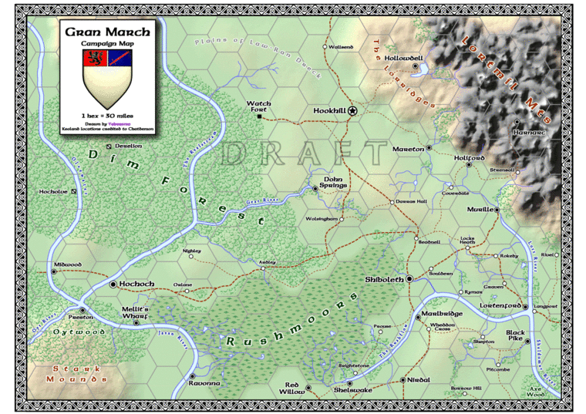

Alternative map of the Gran March
(From Anna Meyer’s website and based on LG material)
https://www.annabmeyer.com/greyhawk-maps/

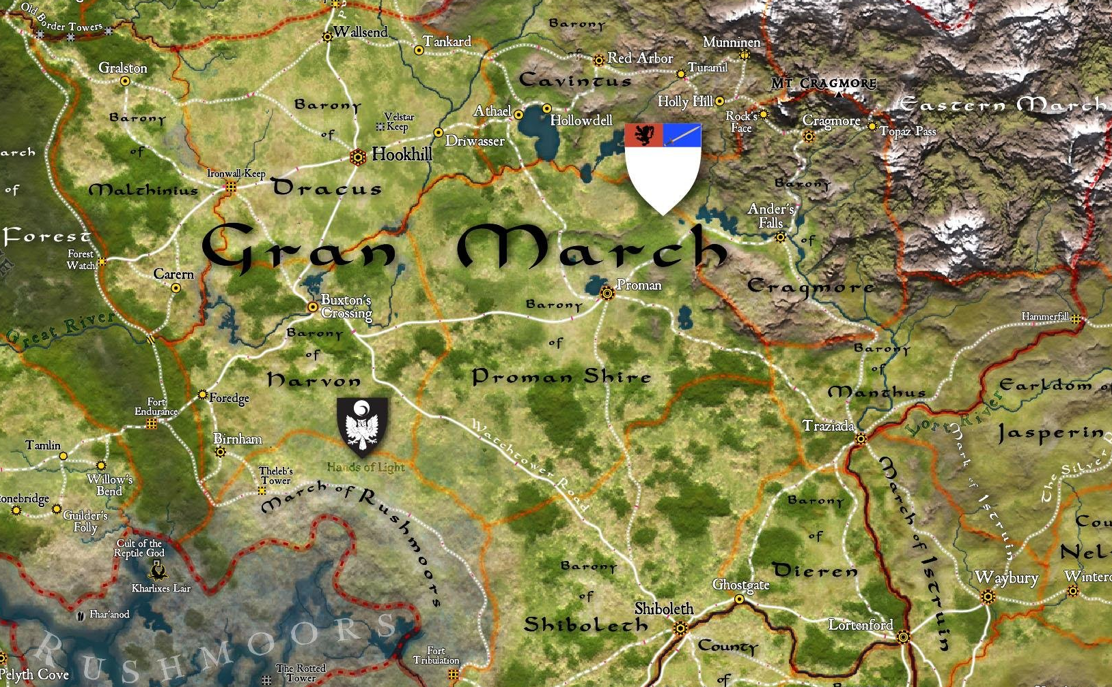

Political map of the Gran March
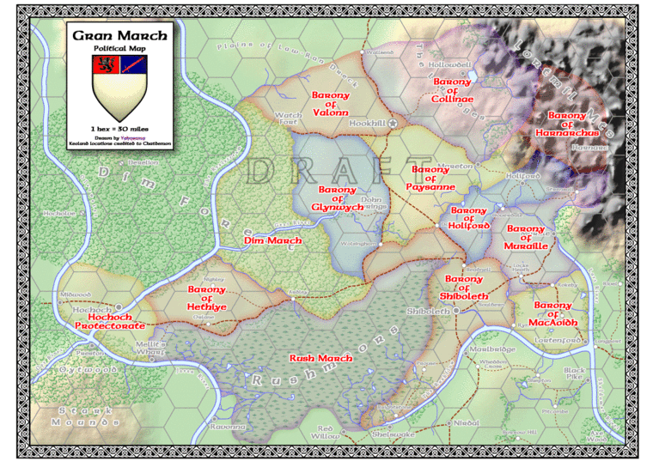

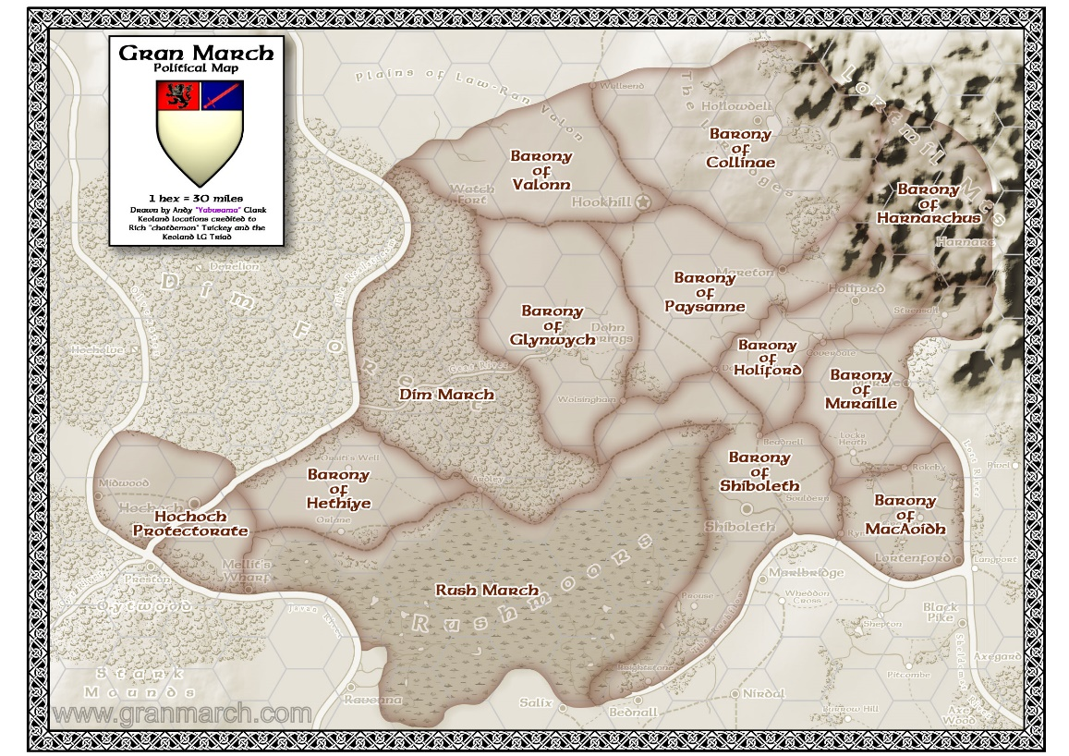

Maps of Hookhill
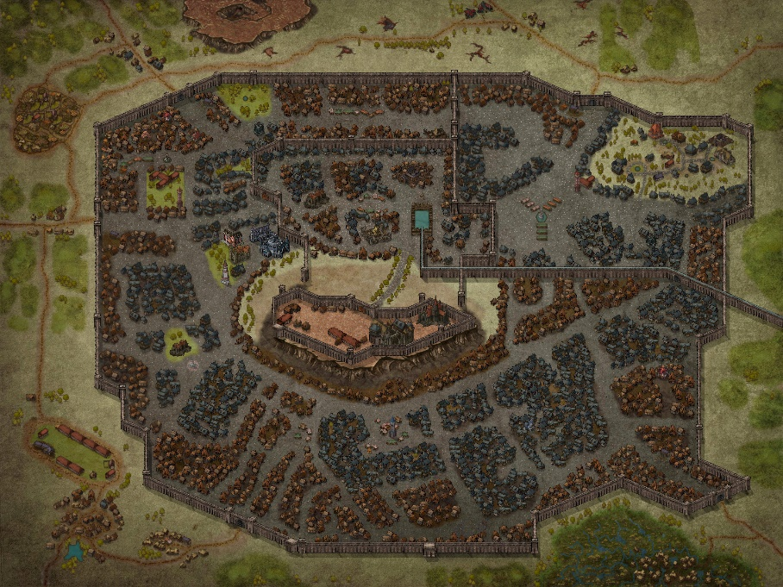
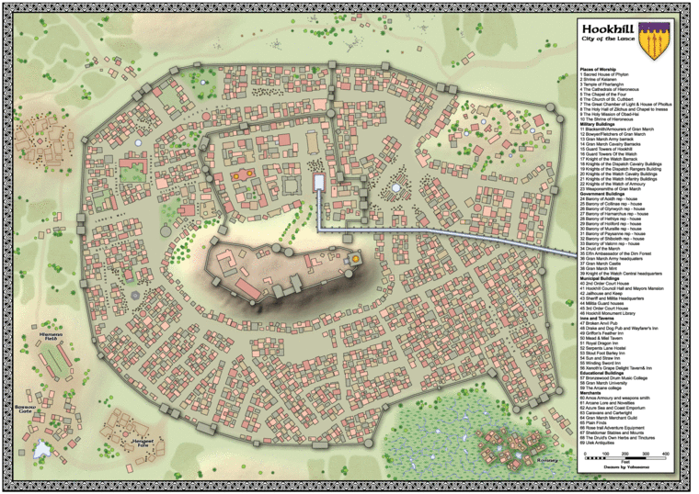

People of the Gran March
Racial breakdown
Humans: 201,017
  - Flan = 36,000
  - Suel = 5,500
  - Oeridian = 21,000
  - Bakluni = 3,000
  - Mixed = 135,517
Elf: 20,356
Dwarf: 12,722
Halfling: 7,633
Gnome: 5,089
Half-elf: 2,544
Half-orc: 2,544

The Gran March is an extraordinarily structured and lawful nation. Its people like to know their place, their rights and responsibilities. Social Classes in the March are often viewed as an obsession by outside observers, and they point to the fact that social classes are ingrained and delineated in the Laws of the March.

However, as is common in feudal societies, the relationship of one person to the next is blurred by myriad intertwining, independent, and sometime conflicting standards. The Laws of the March overlay the ancient Keoish feudal system, and allows for other systems to exist internally. Thus the legal and court systems of the March have evolved to be among the most complex in the Flanaess. The result is a chaotic system that is near unfathomable to outsiders.
Intrinsic in the complex relationships of the March are the underlying principles of rights and responsibilities. Every Institution and each person has rights. Generally, these rights increase as one's social standing increases. Likewise, if ones social standing is higher, one's responsibilities increase.
The most basic responsibility that every Marcher has is to pay taxes as dictated by the March, and to serve in the Military. There are alternative services to military service as defined under the Laws of the March, such as service in the Church. The basic right of every Marcher is to Petition, in the appropriate forum of their Institution. The general hierarchical rankings of social classes is as follows.
- The Members of the Nobility
- The Knights of the Watch
- The Temples
- The Military
- The Guilds
- The Commons

In addition to the Institutions under the Laws of the March, there are three groups which are either outside or unrecognized by the law. These groups have very limited rights in March, but they also have almost no responsibility to the March.
- Allods – Independent Demesnes within the March, the lords of which answer only to the Commandant. Generally, but not always Demi-Human.
- Non-Petitioners – Gran March citizens with limited or no rights, including children and widows of non-veterans.
- Foreigners – the treatment and accommodation of foreigners varies dramatically based upon their origin, but non have legal standing excepting only the nobility of Keoland.

The Nobility
The number of Noble titles in the March is limited in variety. This is due to the descent of the March Nobility from the Keoish Duchy of Dorlain. Technically each noble in the March remains a vassal of the Duke of Dorlain. It is for this reason that there is no title in the March higher than a Grand Baron, other than that of the Commandant. Even today, every Noble pledges vassalage to each liege, in line to the Duke. They do not pledge vassalage to the March, though they do pledge allegiance. The exception to this rule is the Grand Baron of Hethiye, who pledges vassalage to the Grand Duke of Geoff, and through him to the Keoish Crown.
Grand Baron - Noble holder of the 10 baronies of the March, all ten of these baronies were granted by the Duke of Dorlain. A few were replaced by of the King of Keoland, but in each instance the pledge remained. They all owe fealty to the Duke, but that is forgotten or ignored by nearly all, except during the raising of a new Commandant. Some noble houses are actually older than those of the Grand Barons, but they were raised to nobility by other than Keoish Nobility. There is a Baronial family in Hethiye that was raised to its station by the Count of Hochoch before Geoff pledged to Keoland.
Barons/Baroness - These are all nobles of various pedigrees, who were raised at different times during the history of the March. None of these were raised by the Keoish Crown or the Duke, and it is this that sets them apart by tradition. The Barons were raised either by a Grand Baron or other Noble from outside, or predating the March.
Knight Baron, or Baron's Knight - A Knight Baron is a hereditary title. Anyone can be raised to the nobility by a Grand Baron, a Baron or another Knight Baron. Their title is accompanied by lands or manors. Such a Knight has feudal responsibilities as well as rights. They may actually be four or five steps removed from the Baron in their vassalage and feudal obligations, as a Knight Baron can raise another to the title of Knight Baron. However, this is not common, as the Grantor must give up some of their land in order to create a Knight Baron. It is far more common for a Knight Baron to raise another to Knighthood, without lands.
Knight - A Knight is a landless noble. They can be raised to the nobility by a Grand Baron, a Baron or another Knight. Their title is not accompanied by lands or manors. Such a Knight has feudal responsibilities as well as rights, but the title is not hereditary and is not accompanied by lands. They can Knight others, but only with the permission of their liege.
Queen's Knight or Free Lance – This group is an oddity of History, as the March has never had a queen. In fact, a Queen's Knight is technically not a Knight at all. Generally they are not of the nobility. Though it is not widely known, they are in fact an ancient sect which traces its roots to Flannish city states that predate Vecna. They follow an unusual code of honor traveling the land, defending the people and fighting evil. Though they predate the March, they have been present throughout its history, and there has never been significant conflict between the March and the Queen’s Knights. Therefore, they are tolerated by the Military, respected by the people and admired by the Nobility. Throughout the history of the March they have often come to the aid of the Barons, and are therefore treated as near equals. As the Queens Knights rarely ask for more than a night of lodging and a meal, it is an easy relationship. Often, grateful nobles will present arms and horses to wandering knights on feast days. The word of a Knight Baron or a Knight is superior to that of a Free Lance under law. Due to long history of service, a noble who decries a Queen’s Knight will be subject to a great deal of scrutiny by their noble brethren.
Noble Officials - while technically not noble, the servants of the Barons often have some vestige of the prestige attributed to the Barons. This is because they are landholders with feudal obligations to the Baron. Their titles are often Steward, Superintendent, Major Domo, Nuncio, Director, Factor, or Seneschal.

The Knights of the Watch
In the Gran March the Knights do not come under the general restraints of Gran March society. In this they are similar to an Allod, in that they are a law unto themselves. They are governed by their own laws, subject to their own courts, and have broad discretion in overstepping the rights of others “for the Greater Good.” However, the Knights' tradition and their political survival depend upon cooperation and acceptance by the Nobility and the Army. Thus, all knights are generally considered to be the equal of a Baron's Knight. A high ranking knight with decades of service may in fact be treated the same as a newly spurred youth. Their obscure titles of the Knights and their refusal to elucidate their meaning have forced the Knights to accept a somewhat ambiguous social standing in regards to the nobility.

The Temples
As in most parts of the Flaness, the Temples and Churches of the March vary dramatically in their hierarchy and the delineation's between them. Unlike many places, they have a specific legal and societal role in the March. For more information on this, see the Laws of the March. Though there are variances all the churches have three general groups of the clergy. These are:
The Anointed (or various other terms) - Those who draw spells from their patron god are generally amongst this group. These are almost always Clerics or Druids, though other spell casters are accepted in some churches. Individual who show other extraordinary talents, which may be divinely inspired, may be elevated into this category. Talents such as oratory, knowledge or history, or combat skills often draw such attention.
The Dedicated (again this varies) - those who have dedicated their lives to the church, but for some reason never gain the gift of spells. In some churches these members significantly outnumber the Anointed. They handle the bulk of non-religious matters, such as construction of temples and accounting. They also handle many religious rites which do not require immediate magic.
The Laity - those who are devout and may tend shrines and preach, but only on an occasional basis.
Some Churches, particularly the Oerdian Church accept Adepts and other divine spell casters as brothers or sisters and welcome them into the church hierarchy. More details of the individual churches and temples are provided under a separate article, available on the Gran March Website.

The Guilds
Guilds structures vary dramatically in the March, but generally a guild member is considered somewhere between the Military and the Commons in social class. This is not a simple hierarchy, as there is significant overlap between the lower members of the Guild Structure and Boc Holder’s of significant means.
Certain tradesmen, generally those in the service of a noble at their manse, are not members of the guild. However, they can be associated with a guild, and are often accorded status dependent upon the status of the particular guild in society. Guilds are heavily taxed in the March, though their near monopolistic nature makes this bearable.
Guild Masters - Generally one per Guild, though some, such as the various cloth weaver guilds have one per town. They owe a personal tax, which must be presented to the Commandant annually.
Master Tradesmen - someone who is considered a master and able to train apprentices. These guild members are responsible for dues and taxes for themselves and all apprentices.
Tradesmen - These are skilled members of the trade, but they are allowed only one apprentice at a time. They are responsible for the taxes on their work and the work of their apprentice.
Apprentice – Any person subject to guild law, yet not fully a member of the Guild. The apprentice has only the rights accorded him or her under the individual guild rules.
Non Member Tradesmen - These are tolerated outside of trade centers and in the employee of the nobility. They are generally not responsible for taxes as the fruit of their labor is owned by the noble who pays their wages.

The Commons
By far the most numerous of the classes of the March, nearly 70% of the population is numbered among the Commons. While in the Army, persons are members of the Army, not the Commons. Though they occupy the lowest rung of the social ladder, commoners in the March rarely resemble the dejected and downtrodden serfs of other lands. Rather, they are generally veterans or the children of veterans, with significant pride in their rights and responsibilities.

Boc Holder or Bocman - A land holder with recorded charter, almost always a cottage or dwelling and lands. This charter is held at the Baronial seat or in the main town within the barony, generally in a library. These holders owe the baron tax only. Their Charter cannot be revoked except for non-payment of taxes, failure to serve in the army, or certain crimes. All are expected to participate in the defense of the Demesnes.
Sokeman- landholder or herder with only the baron's agreement as charter. Generally this includes a cottage and land, but the holder owes tax and descendants will owe rent. All are expected to participate in the defense of the Demesnes. Right of ownership does not transfer generations. Barons are generally loath to cancel such agreements, verbal or otherwise, as it might cause many Sokeman to leave. However, a Baron can cancel such ownership.
Tofter - a farmer or herder who holds their land at the barons will, owing both tax and rent. There is no right of ownership. Often these commoners owe a certain amount of time working the Baron's lands, serving in his home guard, or working on a public works project. All are expected to participate in the defense of the Demesnes. This is by far the most common arrangement amongst the lords and commons in the March, due to the vast amount of uncultivated land.
Ceorl - a farmer or herder who holds no land but is employed by the baron, receiving food and shelter in exchange for labor. They pay relatively little in the way of tax as they are of limited means. These are more common in the southern areas where farming is more the norm, and where the families have served the lord for generations. Technically, the Ceorl is unable to abandon their employment without the consent of the noble whom they serve. However, most lords grant such a request if it is presented. The vast amount of land available in the March limits the number of Ceorls, and prevents much abuse. If a noble is known for mistreatment of their servants, then they have a hard time convincing the Ceorls to return after their stint in the Army. It is much easier to offer land (which would otherwise go uncultivated), and tie them to the land in this way. All are expected to participate in the defense of the Demesnes.

The Allods
Allods are autonomous demesnes within the March not beholden to any baron, answering only to the Commandant. The rulers of the Allod, and their method of selection vary greatly. The Flan Allods generally have a hereditary chieftain or prince, while Halflings may elect their leadership.
The Allods are governed by their own laws, which may or may not have any relevance to March Law, and while within an Allod, all Marchers are subject to that law. In essence the Allod and the acts that occur there are totally independent of March Law. Persons entering into an Allod agree to subject themselves to the judgment of the Allod. Allods and the persons dwelling within their lands have absolute ownership of their land, and the March has no right to claim, tax or levy the land. They are effectively independant but friendly nations within the corpus of the March.
The Allods understand their place in the world, and only in grave circumstances will a person of high stature or importance treated poorly. By agreement and tradition the Allods have only four responsibilities to the March.
- They cannot make war upon the March or its persons.
- They must contribute to common defense in times of invasion.
- They must provide shelter to any Marcher who would otherwise suffer bodily harm.
- They must provide one representative who will speak for the Allod, and that speaker must present themselves every other year to the Commandant.
There are several dozen of these small demesnes in the March, most of which predate the March, and a few of which predate Keoland. Generally these are Demi Human holdings. There are, however, a few in Flan Allods in Barony Hethiye and several in Holiford Barony, which were annexed by consent, and therefore retain their independence. No Allod are more than twenty square miles, with the exception of the Horselords of the Northern Plains, tribes of Centaurs, which form an Allod with indistinct boundaries.

Baronies of Gran March
Total size of the country = 75600 square miles
Total population = 254,450.
- 227900 in the Baronies
- 17800 in the Marches of the Rushmoor and the Dim forest.
- 7500 in the Protectorate of Hochoch
- 1250 worth of Rhenee and other itinerant travelers.

Barony of Paysanne
Ruler: House Nehelin, Baron Reul Neholin
Capital: Town of Mareton
Size: 5400 sq.miles
Population: 12400
- Army troops located in the barony = 600 troops
Overview: If using LG material, this barony is known as Proman shire and the Capital is the town of Proman (a few miles to the southwest of Mareton).

Barony of Shiboleth
Ruler: House Rholgran, Baron Thynian Rholgran
Capital: City of Shiboleth
Size: 6750 sq.miles
Population: 52900
- Army troops located in the barony = 2000 troops

Barony of Glynwych
Ruler: House Dorh, Baron Eliseus Dorh
Capital: Dohn’s spring
Size: 5400 sq.miles
Population: 12700
- Army troops located in the barony = 600 troops
Overview: If using LG material, this barony is known as Proman shire and the capital is Buxton’s Crossing (same location).

Barony of Hethiye
Ruler: House Heth, Baron Rhodwaed Heth
Capital: Orlane
Size: 4050 sq.miles
Population: 10100
- Army troops located in the barony = 1000 troops
Overview: If using LG material, this barony is known as Farvale and the capital remains Orlane.

Barony of MacAoidh
Ruler: House Aoidthane, Baron Ranlyn Aoidthane
Capital: City of Lortenford
Size: 2700 sq.miles
Population: 48300
- Army troops located in the barony = 1300 troops
Overview: If using LG material, this barony is known as Dieren and the capital remains Lortenford.

Barony of Muraille
Ruler: House Murthane, Baron Othon Murthane
Capital: Town of Murthane
Size: 3375 sq.miles
Population: 24200
- Army troops located in the barony = 900 troops
Overview: If using LG material, this barony is known as Manthus and the capital is called Traziada (same location).

Barony of Valonn
Ruler: House Valon, Baron Reolus Valon
Capital: City of Hookhill
Size: 4050 sq.miles
Population: 10200
- Army troops located in the barony = 3000 troops
Overview: If using LG material, this barony is known as Dracus and the capital remains Hookhill.

Barony of Collinae
Ruler: House Collinae, Lady Edyva Collinae
Capital: Hollowdell
Size: 8100 sq.miles
Population: 17800
- Army troops located in the barony = 2400 troops
Overview: If using LG material, this barony is known as Cavintus and the capital remains Hollowdell.

Barony of Holiford
Ruler: House Holithane, Baron Berengar Holithane
Capital: Town of Holiford
Size: 2700 sq.miles
Population: 20300
- Army troops located in the barony = 600 troops
Overview: If using LG material, this barony is known as Cragmore and the capital is called Ander’s Falls (same location).

Barony of Harnarchus
Ruler: House Harc, Baron Faelan Harc
Capital: Town of Harnarc
Size: 2700 sq.miles
Population: 19000
- Army troops located in the barony = 700 troops
Overview: If using LG material, this barony is no longer a barony and is instead the Eastern March. A new barony is formed to the West of Valonn called the barony of Malthinius with a capital at Gralston (where Watch fort is shown).

Domain of the Rushmoors
Ruler: House Prouse, Baroness Llerith Prouse
Capital: Town of Prouse
Size: 14850 sq.miles
Population: 12500
- Army troops located in the domain = 1000 troops

Domain of the Dim forest
Ruler: House Wolsing, Baroness Anwedd Wolsing
Capital: Audley
Size: 20236 sq.miles
Population: 5300
- Army troops located in the domain = 400 troops
Overview: If using LG material, the capital is called Birnham (same location).

Protectorate of Hochoch
Ruler: Knights of the Watch
Capital: Hochoch
Size: 5400 sq.miles
Population: 7500
- Army troops located in the Protectorate = 3500 troops. These are purely troops supplied by the Gran March, other countries have also provided troops to retake Geoff.

The Army
For Commandant and Country, I do solemnly swear that I will serve with true faith and allegiance in the Gran March military, that I will support and defend Gran March against all enemies foreign or domestic, that I take this obligation freely without reservation or purpose of evasion, and that I will discharge my duty well and faithfully, by my honor and by my god.
Oath of Induction, Gran March Military.

The Gran March was originally established as a vassal state of Keoland, based on a military religious Order of Knighthood: the Knights of the March.

Internationally renown mailed cavalry forms the core of Gran March's impressive army. Armed with lances, crossbows, and swords, these riders are the bane of giants inhabiting Geoff. The Knights of the Watch and Knights of Dispatch offer support and welcome tactical expertise. The total standing army includes more than eighteen thousand soldiers. At least three times as many trained troops can be called up within a single week.

Its own troops, among which mailed cavalry is of exceptional quality, suffered little in the way of casualties during the Greyhawk Wars. It has also received the cream of exiles from Bissel, Geoff (who fled there because it was nearest), and Sterich (who fled there rather than to distrusted Keoland).

The Gran March military is the uniting factor of Gran March society. As every male must serve, and many females choose to serve, the institution unifies the classes. It also provides the populace of the March the experience of travel and a degree exposure that most commoners of the Flaness do not receive.

Participation in the military breaks feudal bonds and allows for a level of social freedom and advancement not found in most other Kingdoms. It allows the masses to earn wages not dependant upon the local lord’s whim. Also, a noble or guild cannot force a soldier to return from duty, and the Army jealously guards this privilege. Even attempts to indirectly influence a soldier, by exerting pressure on family as an example, will find themselves incurring the wrath of the military establishment.

The Equality of Might edict
When the Gran March gained its independence from Keonalnd, one of the edicts that was put in place is the edict called Equality of Might. This edict was implemented to ensure the no single group, originally targeted at the Knights of the Watch, would hold military sway over the individual nobles of the country. What started off as an edict to redress military power gradually evolved over time into a way of life for the country.

At first the edict forced the Knights of the Watch to train the warriors from the various faction within the Gran March in combat. As each faction, great and small, wanted to ensure their own independence this evolved into becoming a mandatory conscription for all fit males for a period of up to seven years.

At age fifteen, after having complete any apprenticeships, all fit males enter mandatory conscription for a period of up to seven years. Girls may join the rank and file, as well, though this is something of a modern development, and their participation is not seen as mandatory (though several influential women in the military hierarchy believe it should be). It is a testament to the national pride of the nation's young people that many continue after their required service, and those who do not are generally members of local militias.

Mustering day
Mustering Day is perhaps the single most important holiday in the nation of Gran March. On this day, all those soldiers who have completed their mandatory term of service in the Army (or the work gangs for those who are not deemed fit for service in the Army) are mustered out, and a fresh batch of fifteen-year-old boys and girls are mustered in to begin the process by which they will become highly-trained soldiers in one of the most formidable armed forces the world of Greyhawk has ever known. It is, as one might imagine, both a day of great national pride and a day of great national sadness, as many hundreds of mothers (and fathers) watch their children leave home to enter a life of discipline, service, and danger.

Those who may be physically unsuited are put to work in clerical (office work) positions. Those unfit by reason of temperament are placed in the work battalions building roads and draining swamps. Only those who are so impaired that service of any kind would be impossible are released. This includes the severely crippled, the blind, and the severely mentally retarded. It is an indication of the intense patriotism of the population that even those that fall into this category often beg to be found able. The tale is told round many a hearth of the blind bard Riccman whose song is said to have turned the tide at the battle of Habler’s Pass. Females are given the option of service but are not conscripted.

Female conscription has become a hot topic among the ranking officers, but given that young females provide the backbone of the workforce, this is unlikely to occur in the near future. The Gran March government considers citizens who do not make themselves available for service to be traitors and will punish them by death unless they can show good cause for their actions.

Non-citizens entering Gran March for an extended period are given a choice. Males of suitable age must either report for service the next Mustering Day or they and their families must move on as soon as practical. Those who do serve (and their families) become citizens by virtue of this service. By treaty, sylvan elves of the Dim Forest are exempt from conscription. However, they are permitted to join voluntarily and many do so in order to receive training and the other benefits of service.

Army breakdown

The 18000-person army is divided into three trooper status; the nobles, the core and the conscripted.
Nobles - These are members of the nobility that are part of the military. They are the leaders and mostly all heavy cavalry. They rule over the military training camps and the defensive keeps throughout the country. Roughly 20% of the army consists of members of the nobility – of which 2500 are Knights of the Watch.
The Core – These are full time members of the army that have completed their seven years of conscription and decided to stay on for may more years. They hold positions of importance within the army; such as trainers, master guildsmen, quartermasters, etc. The Core forms roughly 10% of the army. Four hundred of which are the Queen’s Knights.
The Conscripted – These are recruits who are serving their seven years with the army. They form the bulk of the Gran March’s army – roughly 70%.

Although there are variations from year to year, the army itself has roughly the following breakdown of troops:
Cavalry – 7500
- Heavy: 3200 (heavily armored shock troops.)
- Medium: 3000 (Medium armored mobile infantry. Armed with lance or spear as well as well as infantry weaponry.)
- Light: 1300 (Light or no armor. used as scouts, skirmishers, and to ride down a routed or broken foe. more mobile than all other cav)
Foot - 8500
- Medium: 5500 (medium armored, spears and pikes are the primary weapon)
- Archers: 3000 (light armor, crossbows and longbows are the primary weapon)
Specialty Corp - 950
- This group would include any soldier whose mission falls outside of any other group, yet are still considered combatants. Examples would be Trackers, Mariners, Engineers, Etc.
Magic Users - 600
- This group includes any type of spellcaster whose primary duty is to support the main combatants. These guys may have to swing a sword to defend their lives, but are by no means the front-line fighters.
Siege/Heavy Weaponry - 450
- This group is responsible for the care and feeding of the war machines. This is not a sizeable group since Gran March is not a besieging force, yet they are present because one can never tell when a siege engine will be needed.

Army ranks are divided as follows.
Infantry and Archers
- Lord Marshal of the Infantry – Reports directly to the Lord Commandant. Must be a noble. Leads an Army.
- Lord Brigadier – Must be a noble. Leads a Brigade.
- Lord Colonel or Colonel – Highest rank available for a non-noble. Leads a Battalion.
- Lord Major - Lowest rank for a noble. Leads a Company. Although both Majors and Captains lead Companies, a Major outranks a Captain (due to him being a Noble).
- Captain – leads a Company
- Lieutenant – leads a Platoon
- Sergeant – leads a Squad
- Private
Cavalry
- Lord Marshal of the Cavalry – Reports directly to the Lord Commandant. Must be a noble. Leads an Army.
- Lord General – Must be a noble. Leads a Regiment.
- Lord Colonel or Colonel – Highest rank available for a non-noble. Leads a Squadron.
- Lord Major - Lowest rank for a noble. Leads a Pride. Although both Majors and Captains lead Prides, a Major outranks a Captain (due to him being a Noble).
- Captain – leads a Pride.
- Coronet – leads a Troop.
- Lance Corporal – leads a Lance.
- Trooper (Private)

Equipment
The following equipment is the typical attire of the commoners serving in the military. Nobles have access to better equipment.

Infantry: The average infantryman wears leather armor and wields a longspear as his main weapon, with a short sword for close-in combat. A unit of eight infantrymen is called a Squad and led by a Sergeant. A Sergeant is armed with a greataxe or greatclub, carries a crossbow, and is protected by scale mail. Four squads are grouped together into a Platoon, which is led by a Lieutenant riding a light war-horse, wearing chainmail, and armed with a long sword and shield. A Company, led by Captain (armed as Lieutenant), consists of three platoons plus two support squads; a Company numbers 130 troops.
Archery: Archers are armored with leather and are issued light maces for hand-to-hand combat, although they are trained to avoid this. Where they shine is in the use of their longbows. A Sergeant wears studded leather armor and a Lieutenant has scale mail. Captains ride a light war-horse, wearing chainmail, and armed with a long sword and shield. An archery squad consists of 9 archers led by a Sergeant and is called a Half-Quiver. A Platoon, led by a Lieutenant, consists of two squads and is called a Full Quiver (or simply, a Quiver). A Rain, led by a Captain, consists of five Quivers and two infantry support squads; a Rain numbers 124 troops.
Cavalry: The average cavalryman rides a warhorse, wears chainmail and fights with long sword, crossbow, and heavy lance (sized appropriately). Light cavalry units posses all unarmored, fast horses. They are used for scouting or harassing enemy encampments. Medium cavalry is used for most jobs; the horses are heavier (if slower) and the Captain’s horse is armored. If battle is imminent, especially if the other side has a concentration of archers, all horses can be armored thus designating the unit as Heavy cavalry. In cavalry units, neither Lance Corporals nor Coronets are armed in a significantly different manner from the common trooper. A Captain is usually in full plate armor and his horse (a heavy warhorse) is also armored unless the tactical situation demands otherwise. The basic cavalry unit is a Lance, formed of five troopers and led by a Lance Corporal. Cavalry platoons are called Troops and consist of 4 Lances. Multiple Troops (usually three) form a Pride with some additional mounted support troops. Cavalry Prides are defined as light, medium, or heavy. The number of squadrons in a given pride and the equipment assigned is based on tactical necessity. All cavalry Prides are capable of fighting in any given mode, although some do prefer one over the others. The average Pride consists of 80 troops.

Life in the army
To facilitate the training of new recruits, military training camps were set up in each Barony, usually near the largest settlement. As a general rule, when not patrolling, troops complete training in their chosen trade (blacksmithing, carpentry, etc) or manage the farmland set aside for the army. Apprentice guildsmen work under a master of the trade who is a member of the army. In this way, the army is self-sufficient for most of the goods they need. Any surplus goods produced become the property of the army and are sold off to procure what they army cannot manufacture for itself. In addition, land is set aside for the army members to farm and feed livestock so that they are an autonomous entity.

Although army members are not prisoners, leaving the military camp without authorization is penalized. The troops are granted regular leave four times a year; a three-week period between each season. For the week prior, during and after each seasonal festival, the army recruits are granted time off. An interesting follow on effect of this is that to maintain military readiness during those weeks, a portion of the veteran troops are called back to duty to serve. This is not perceived as a burden as many of them look forward to reuniting for a few weeks with army friends who have settled elsewhere in the Gran March. It also gives the veterans the opportunity to get away from their farms and regular lives to catch up on news and refresh their training in weapons.

Basic Training
The first year of a conscript’s service is spent in basic training, which is conducted by senior army members. This involves training in all forms of combat (foot, mounted, and archer) as well as classes in literacy, military history and protocol, tactics, and logistics. There is also a great deal of drill. During this period, those recruits who show special talent are noted. At the end of one year, those recruits are sent for further training in their specialty. The military is always on the lookout for those who show magical aptitude (whether indicated by a special relationship with one of the gods or by an ability to channel other types of magic) and all recruits undergo a test for this.

Nobles undergo a modified training as it is assumed that they already possess fundamental training in fighting. Therefore, their training focuses more heavily on tactics and logistics. The upshot of all this is that all soldiers can read, can ride, and can command in battle in extremis. This serves to give commanders a great deal of flexibility on the battlefield On the Mustering Day following basic training, the conscript is assigned to the unit that best fits his or her skills. Soldiers assigned to the Spellcaster Corps undergo an additional year of training before being assigned to regular duty. They are also required to serve an additional year in their initial enlistment term (not to exceed the seven year maximum) in order that the army may receive full benefit from this additional training investment.

Second and third years
After a soldier has completed their first year of training, they are typically assigned to man outposts and garrisons throughout the Gran March. They chase down bandits, guard the roadways, as well as hunt down dangerous animals and monsters.

Fourth and fifth years
Soldiers who have completed their third year of training and deployment are judged for their maturity, temperament, talents, and aptitudes. Those that show promise of being able to maintain calm and the ability to diffuse tense situations are put into the various city watch of the larger settlements. Others are recruited by the nobles as personal guards for their manors, keeps and castles.

Sixth and final years
Soldiers that have completed their fifth year can apply for the elite squads, platoons and companies that are spread throughout the Gran March. This includes various prestigious organization such as:
- The Commandant's First Company or more commonly known in the Gran March as "The First" -- i.e. "I am a member of the First". This company of 100 troops serve directly under the Commandant. It is the only Company in the whole of the Gran March to be directly under the Commandant's purview. To become a member of this Company, the soldier must have completed at least 5 of their mandatory seven years of service. The members of the First are selected for their fighting prowess, proven loyalty to the Gran March and discretion -- as they will be in situations to overhear sensitive topics. Members of this Company are proud and take their role very seriously.
- "The Company of the Deep", comprised of elite military scouts that specialize in guerilla warfare tactics and woodcraft. Each member of the company is outfitted with studded leather armor, a long or short bow and arrows plus a short sword and dagger. Most also pick up a sturdy staff during their stay in the wilderness. They are also provided a backpack, flint and steel, mess kit, 50ft rope, 2 flasks of oil, a water skin and a whetstone. This company patrols deep into the forest and interacts with the elves of the Dim Forest. They spend their time away from civilization except to replenish basic supplies. A member of this company is fluent in the Elven dialect as well as Elven culture. The company is lead by a Captain and consists of two platoons. Each platoon of "The Deep" consists of 36 soldiers, led by a lieutenant. The company consists humans and elves and provides diplomatic relationships with the Sylvan and Wild Elves of the Dim Forest.
- Squad 13 numbers no less than 4 members and no more than 12 members at any one time. Only candidates who not part of the nobility and have completed their fifth year of mandatory service are accepted into this squad. The squad reports to the Knight of the Watch known as the Inscrutable Sphinx. Candidates are selected for their innovation, perseverance, and adaptability. This squad is used for missions not suited for standard soldiers and are frequently deployed outside of the Gran March.

Awards
Awards for valor in increasing order are:
- The Baronial Medal of Valor
- The Commandant’s Shield
- The Sword of the March
- The Sign of Trilesimain (this is only given posthumously).

Pensions
The families of those killed in battle receive a pension annually. Those who are injured in service so badly that they cannot work receive also receive a pension annually. The various awards also include pensions, which are cumulative with those above.

Reserves
All former military personnel are considered to be in the reserves for “as long as they may profitably serve.” Reservists who maintain residences in Gran March are organized into local groups called militias; so-called “adventurers” who have no permanent home need not join a militia unit. Besides providing callup duties and maintenance of military training, these also serve as social clubs.

Relationships
Commoners have a strong loyalty not for the Knights and certainly not for the nobility, but for their own towns, villages, hamlets, etc. There is a collective identity that says, "If I let this town fall, my town might fall next." The commoners have been raised listening to the tales of Knights of the Watch and being so caught up in the ideas of honor, valor and justice that even thought they will never make knighthood, they'll prove that they will at least meet as equals in tenacity. And because they are caught up in those tales, they see a national identity. No longer do the commoners of Three Firs see the village of Whitestone as Them (citizens of Whitestone), but they see the village of Whitestone as OUR village.

Although there is no love for the knights, there is no distain either. The commoners are simply disconnected from the knights. At times of peace, the commoners are too busy going about their business to notice the on-goings of knights. In times of war, the commoners realize that knights are professional soldiers and although the commoners are well trained, they know little about strategy and tactics and all that other "knightly stuff." One can imagine an older infantry pikemen saying to a younger, more loud mouthed pikemen, "Hey we don't question the knight. He knows how to fight a war, that's why he's a knight."

The nobility and the Knights are a different matter. Depending on the case, the nobility may or may not be knights. In one regard, the nobility defers to the knights. On another, the knights defer to the knighted nobility. Yet on another, the nobility, not being knights, may not defer because they have their own particular interest (though that would be rare). A venerable and experienced Baron may not defer to some young 27 year old knight who is facing his first command.

Noble house of the Gran March
Below are details of each noble house of Gran March and its heraldry. The House and related nobles are broken down in the following way.
- House name and Status (Major or Minor house)
- House colours
- Racial make-up
- Location
- House leader
- Population of the House
- Other important nobles of the house
- Knights of the House
- Patron God
- Wealth
- Industries
- Description, which includes political leaning and involvement as well as any intrigues

House Nehelin (Major house)
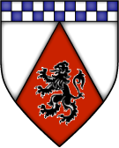
Racial Make up
Mostly of Suel extraction with Oeridian blood mix. Descendants of the Suel House Neheli
Location
Paysanne, the manor is on the edge of Mareton
House Leader
Lord Baron Reul Neholin
Population
- Sokeman - 300
- Ceorl - 2,500
- Cotter - 700
Military
- Militia of 900
Other Nobles
- Bosser Ryane (7th Aristocrat; 1st Warrior)- mayor of Mareton
- Lady Allya Neholin (Ryane) (7th Aristocrat)
- Lairwir Neholin (5th Aristocrat; 1st Warrior)
Knights
- Sire Tallia Nehelin
- Sire Gerjos Benthor
- Sire Rednar Ryane
Patron God
- Phyton
Wealth
- 10,000gp per annum
Industries
- Cloth, Horse Breeding, some Sheep Farming/Wool and Silver Mining
Description
- This house traces its bloodline to the Neheli family of Keoland. It changed its name after the Small War to avoid the derision of the other houses who vehemently opposed Keoland's appointees. Unlike House Rholgran they tried and mostly succeeded to keep out of the lime light of the transition to elected Commandants.
- Lord Soloim of the house at the time was careful not to fracture the growing independent feeling of the houses and was instrumental in "convincing" House Rholgran to enter the fold thus avoiding civil war. Since then the House has be seen as one of the leading diplomatic forces in Gran March especially between Keoland and Gran March. Today it rests mostly on those laurels.
- The present Lord of the manor, Lord Reul is old and coming close to end of his rule of 50 years. His second wife Lady Allya is younger and more ambitious.
- Lord Lairwir, the heir to the manor since the death of his elder brother in the retaking of Hochoch, is a lazy lout who spends much of his time complaining at the cooks about their inability to cook like the chefs of King Skotti in Keoland.
- Sire Tallia Neholin, Lord Reul's daughter, chose to become a knight serving the House after volunteering in the Gran March army for 5 years. A true leader her troop is the envy of the other houses. Both children are of Lord Reul's first wife.
- Lady Allya hates Lairwir and would entice the more than willing cooks to poison him if she did not fear Tallia.
- Lady Allya's brother, Bosser is almost as ambitious as she and it is said that various unsavoury folk have been seen come and going from his estate but he is careful not raise too much suspicion. Given the job of mayor by Lord Reul at Lady Allya's behest, His Worship Bosser Rayne has suggested to Lady Allya that she seek a greater alliance with Keoland and House Rholgran.
- Sire Tallia fears for her brother and has planted spies within the cooks and guards to keep an eye on him and warn her of any in pending danger. Tallia is wary of Allya and her brother. She senses their ambition. She hopes beyond hope that her brother Lairwir can change and be the leader that the barony needs after her father dies but in her heart she knows he is not a leader. A supporter of Gran March independence she an ally to Lord Lyndus in Hookhill.
- Lord Lyndus encourages Tallia to learn more of her Fathers skills in running Manor but Tallia prefers battle and the open plains to counting money and clandestine meetings. However Tallia has had to be the House's representative in Hookhill due to Lairwir's lack of interest.
- The third richest House in Gran March the Ceorl and Cotters are reasonably well off and generally like their ruler. They know and respect Tallia as well as Rednar. Gerjos is a restrict feared leader of his Militia but no one can accuse him of being unfair.
- The Milita is made from Freeman Ceorl and Cotters alike who have served time in the Army. They are called up one on a monthly rotation so they are able to get their work done.
- The House is know to have some of the finest horses next to Valon and their cloth competes well with Rholgran. The silver mining on the far eastern boarder is controlled by small group of gnomes who pay tribute to the house for protection and export.

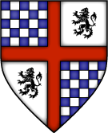
House Rholgran (Major house)
Racial Make up
Mostly of Suel extraction with Oeridian blood mix. Descendants of the Suel House Rhola
Location
Barony of Shiboleth, City of Shiboleth
House Leader
Lord Baron Thynian Rholgran
Population
- Sokeman - 100
- Ceorl - 3,000 in the lands around Shiboleth
- Cotter - 700
Military
- Militia of 800
Other Nobles
- Lady Anicia Rholgran
- Lady Margeria Rholgran
- Lord Gocelin Rholgran
- Lord Alward Rholgran
Knights
- Sire Delran Rholgran
- Sire Farvee Cappe
- Sire Firmin Coddyng
- Sire Ranulph Rholgran
Patron God
- Lydia (one of the Suel gods of Keoland)
Wealth
- 11,000gp per annum
Industries
- Cloth, dyes and exports
Description
- Being the major exporters to southern Sheldomar Valley has made House Rholgran one of the richest Families in Gran March. They are also one of the least trusted. House Rholgran was the last to join the Nobles confrontation with Keoland. Baron Ornereus Rhola refused to join the nobles believing that Gran March should remain dependant on Keoland. After a clandestine meeting of his brother Gervase and Lord Soloim (of Neholin) had Ornereus removed from power. Only later to have be found dead in the Rushmoors.
- The exact sequence of events are cloudy but historians have felt that Ornereus was murdered by his brother and the other houses agreed to turn a blind eye for Gervase's support but no evidence of this can be found. Gervase followed the Lord Solomin's lead and changed the name of his family to Rholgran take on the Gran of Gran March to prove his allegiance. Gervase also sent emissaries to Keoland promising to remain loyal to House Rhola and to advocate for Keoland in Gran March. News of this caused uproar among the other Nobles but once Keoland succumbed to other barons' wishes and rebuked House Rholgran, it was reluctantly accepted back into the fold. Neither House Rholgran nor the other baron released that it was on Lord Solomin's advice that Keoland rebuke Rholgran to maintain peace and to show that it was concerned for the well being of Gran March.
- After the death of King Tavish the IV, House Rhola of Keoland sought some reconciliation with House Rholgran, which achieved some measure of success. Today the Houses are on friendly terms and are major drivers of trade between the two regions. After the unexplained death of Gervase the House move into Shiboleth completely claiming the old Manor to be cursed. Today they control much of the centre and north of the city.
- Lord Alward, Thynian brother, is the mayor of Shiboleth. Cousins to Thynian, Sire Ranulph is the bailiff and Sire Delran is Captain of the guard. Lord Baron Thynian is Honorary head of the Cloth Guild while his wife Lady Anicia is has the same title of the Dyer's guild. His sister Lady Margeria is an accomplished trader and has earn the reluctant respect of many of the merchants of Shiboleth. There is not much that can go on in Shiboleth without Lord Thynian hearing about it. He has his own small group of spies with in the city. He has heard rumours of the Black Willow guild operating in Hookhill but he has not yet learned that they have courting his sister, Margeria, persistently Lord Gocelin, Thynian brother, is the house's representative in Hookhill.
- The houses relationship with Hookhill is strained. Thynian hates Lord Lyndus and considers him a meddlesome fool. He does have a cordial relationship with The Commandant who he knew when Magnus was stationed in Shiboleth. Lord Thynian cannot understand why Vrianian had need of such a man as Lord Lyndus but has agreed not to discus this with the Commandant as they have agreed to disagree about Lord Lyndus and his station.
- In truth the Commandant's advisor Lord Lyndus has come close to uncovering Thynian ever increasing alliance with House Rhola in Keoland. These talks appear to nothing more then about trade and the movement Shiboleth goods beyond the Sheldomar Valley. In fact they are about helping House Rhola reacquire the crown of Keoland and Rholgran reward for such support.
- Sire Farvee and Firmin patrol the Rholgran lands west and east of the city respectively. Farvee is pressed more often by creatures and humanoid excursions from the Rushmoors and has a larger portion of the Militia then Firmin.
- The Freeman and serfs outside the city have an easier life then those within its walls. All of the Cotters are inside the city.
- The House sells the best cloth and dyes in the Valley. They are heavy sought after in the great city of Greyhawk.

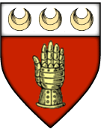
House Dorh (Major house)
Racial Make up
Oeridian and Suel mix
Location
Barony Glynwych; Near the town of Dohn Spring
House Leader
Lord Baron Eliseus Dorh
Population
- Sokeman - 300
- Ceorl - 1,000
- Cotter - 300
Military
- Militia of 750
Other Nobles
- Lord Godhuwe
- Lord Mauger
- Lady Lecia
- Lord Roul
Knights
- Sire Maryota Alberd
- Sire Hugone Dorh
- Sire Osbert Dorh
Patron God
- St. Cuthbert
Wealth
- 7,500gp per annum
Industries
- Lumber, Wool, some horse and Cloth as well
Description

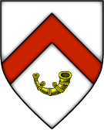
House Heth (Major house)
Racial Make up
Oeridian and Flan mix with a smattering of Suel
Location
Barony of Hethiye; Near Nighley
House Leader
Lord Baron Rhodwaed Heth
Population
- Sokeman - 600
- Ceorl - 700
- Cotter - 200
Military
- 700
Other Nobles
- Lady
Knights
- Sire
Patron God
- St. Cuthbert
Wealth
- 7,500gp per annum
Industries
Description

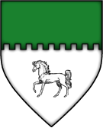
House Aoidthane (Major house)
Racial Make up
Oeridian Suel and Flan mix
Location
Barony of Aoidh; near the city of Lortenford
House Leader
Lord Baron Ranlyn Aoidthane
Population
- Sokeman - 500
- Ceorl - 750
- Cotter - 300
Military
- Militia of 800
Other Nobles
- Lady Hieronia Aoidthane
- Lady Osanna Aoidthane
- Lady Idonea Aoidthane
- Lord Elias Aoidthane
Knights
- Sire Iffer Aoidthane
- Sire Thoma Purlles
Patron God
- Hieroneous
Wealth
- 9,500gp per annum
Industries
- Cloth, Farming, Exotic food and import export
Description

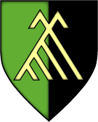
House Harc (Major house)
Racial Make up
Flan with traces of Oeridian
Location
Barony of Harnarchoch; Town of Harnarc
House Leader
Lord Baron Faelan Harc
Population
- Sokeman - 600
- Ceorl - 0
- Cotter - 0
Military
- 600 Volunteers
Other Nobles
- Lady Ita
- Lord Segene
- Lord Manchan
- Lady Vanora
- Lord Niall
Knights
- Sire Ysemay
- Sire Juel
- Sire Ouin
Patron God
- Obad Hai
Wealth
- 9,000gp per annum
Industries
- Mining and Mineral Trade, some smelting as well
Description

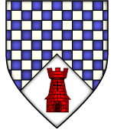
House Murthane (Major house)
Racial Make up
Oeridian, Suel and Flan mix
Location
Barony of Muraille; Town of Murthane
House Leader
Lord Baron Othon Murthane
Population
- Sokeman - 250
- Ceorl - 1,500
- Cotter - 200
Military
- Militia of 745
Other Nobles
- Lady Jehanne Murthane
- Lord Galien Murthane
- Lord Renier Murthane
- Lord Lyndus Murthane
Knights
- Sire Begue Wylymot
- Sire Ermessenda Murthane
- Sire Rixenda de Casse
- Sire Yon Murthane
Patron God
- St. Cuthbert
Wealth
- 8,500gp per annum
Industries
- Wine, Fine Foods and Clothes
Description

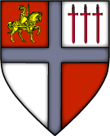
House Valon (Major house)
Racial Make up
Oeridian and Flan mix
Location
Barony of Valonn, Hookhill and north of Hookhill
House Leader
Lord Baron Reolus Valon
Population
- Sokeman - 900
- Ceorl - 1,000
- Cotter - 450
Military
- 900 Conscripts
Other Nobles
- Lord Clothair
- Lord Dreux
- Lord Tescelin
- Lady Ogiva
- Lady Emma
- Lady Waldrada
Knights
- Sire Folmar
- Sire Allowin
- Sire Joveta
- Sire Rothad
Patron God
- Zilchus
Wealth
- 12,000gp per annum
Industries
- Horse-breeding, Wool, Tanning, Lumber, Caravans to the north
Description

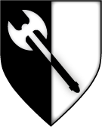
House Collinae (Major house)
Racial Make up
Oeridian, Suel and Flan mix
Location
Barony Collinae; Next to the town of Hollowdell
House Leader
Lady Baroness Edyva Collinae
Population
- Sokeman - 800
- Ceorl - 550
- Cotter - 300
Military
- Miltia of 800
Other Nobles
- Lord Aldred
- Lord Bodwine
- Lady Leurona
- Lord Wulurich
Knights
- Sire Seyua
- Sire Leffeyne
- Sire Galfrid
- Sire Helouyn
- Sire Wulvella
Patron God
- Hieroneous
Wealth
- 8,000gp per annum
Industries
- Mining, Horses, Dyes and Wool
Description

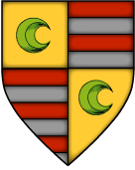
House Holithane (Major house)
Racial Make up
Oeridian, Suel and Flan mix
Location
Barony of Holiford; Town of Holiford
House Leader
Lord Baron Berengar Holithane
Population
- Sokeman - 450
- Ceorl - 900
- Cotter - 255
Military
- Militia of 600
Other Nobles
- Lady Heleanor
- Lord Karles
- Lord Droart
Knights
- Sire Imblen
- Sire Odinel
- Sire Loyset
- Sire Yvain
Patron God
- St. Cuthbert
Wealth
- 7,000gp per annum
Industries
- Clothes, Farming and some Mining
Description

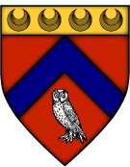
House Dassas (Minor house)
Racial Make up
Suel and Oeridian
Location
North of the Border in Paysanne next to the Town of Dassas Hall
House Leader
Lord Amatus Dassas
Population
- Sokeman - 150
- Ceorl - 800
- Cotter - 100
Military
- Militia of 400
Other Nobles
- Lord Thonyn
- Lord Clyment
- Lady Cicilia
Knights
- Sire Domenyk
- Sire Pheliset
- Sire Fithian
Patron God
- Pholtus
Wealth
- 6,000gp per annum
Industries
- Cloth and Farming
Description

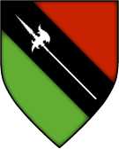
House Wolsing (Minor house)
Racial Make up
Oerdian and Suel mix and smattering of Flan
Location
Straddles the Border of Glynwych and Shiboleth; Includes the town of Wolsingham
House Leader
Lady Baroness Anwedd Wolsing, Defender of the domain of the Dim Forest.
Population
- Sokeman - 350
- Ceorl - 1,120
- Cotter - 254
Military
- Militia of 400
Other Nobles
- Lord
Knights
- Sire
Patron God
- St. Cuthbert
Wealth
- 5,200gp per annum
Industries
- Cloth, Lumber and Farming
Description

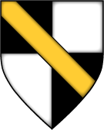
House Souldthane (Minor house)
Racial Make up
Oerdian, Suel and Flan mix
Location
In the town of Souldern
House Leader
Lord Clarwydd Souldthane
Population
- Sokeman - 100
- Ceorl - 600
- Cotter - 135
Military
- 320 Militia
Other Nobles
- Lady
Knights
- Sire
Patron God
- Fharlanghan
Wealth
- 4,000gp per annum
Industries
- Cloth and Farming
Description

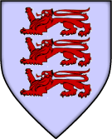
House Prouse (Minor house)
Racial Make up
Oerdian
Location
Near the town of Prouse on the edge of the Rushmoors
House Leader
Lady Baroness Llerith Prouse, Defender of the domain of the Rushmoors
Population
- Sokeman - 300
- Ceorl - 750
- Cotter - 175
Military
- 260 Militia
Other Nobles
- Lord
Knights
- Sire
Patron God
- Pholtus
Wealth
- 6,000gp per annum
Industries
- Madder Dye and Fine Foods
Description

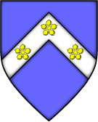
House Stren (Minor house)
Racial Make up
Oerdian with Flan mix
Location
In the town of Strensall
House Leader
Lord Donwric Stren
Population
- Sokeman - 125
- Ceorl - 450
- Cotter - 375
Military
- 200 Militia
Other Nobles
- Lord
Knights
- Sire
Patron God
- Hieroneous
Wealth
- 5,000gp per annum
Industries
- Mining and Smelting, some Lumber
Description

Flavor

A Knightly Society
The Gran March is a huge knightly holding. While there is now a government technically separate from the Knights of the Watch (formerly Knights of the March), the Order of Knights remains the single most powerful and defining characteristic of the March. The government functions as much as an adjunct to the Order of Knights as an independent sovereign. The society is a knightly one, and the culture is a knightly one, more than anything else. This is not, however, absolute and is changing.

The Gran March Comes of Age
Since the Short War, the Gran March has had to, in a sense, grow up. It is no longer just an appendage of Keoland. While technically allied to Keoland, it functions for all practical purposes as a completely independent state. In fact, the Gran March has grown to rival Keoland in influence in the north. Nothing happens from Thornward to Shibboleth without the Gran March being involved and approving. Keoland’s writ now runs north only to the Rushmoors and the Rushflow. Beyond the midwaters of the Sheldomar Valley, the Gran March is the power with whom to be reckoned in military terms. Keoland, however, is vastly more wealthy than the March and its financial assistance is the source of its continuing influence in the north.

Keoland and the March
This is not to say that Keoland and the Gran March are adversaries or rivals, but no longer will the Gran March immediately bow to the commands of the Lion Throne. The Gran March is coming to see its interests as at least as important as Keoland’s interests and is increasingly assertive. Where once Keoland commanded, now they must negotiate. This sits not well with certain factions within Keoland and to this extent, a rivalry has developed.
The situation is complicated, however, because the Order of Knights exists not only in the March and in Bissel, but also in Keoland proper. At least a quarter of the Order belong to chapterhouses situated in Keoland, most dating back to the days of the Knights of March, now subsumed into the Knights of the Watch. The international, or inter-regional, character of the Order of Knights places checks on both Keoland and the Gran March in how they deal with each other.
The parameters of the new relationship between Keoland and the Gran March are being put to the test in Geoff. The Gran March stands in the forefront of the liberation of Geoff and it intends to have a continuing influence once Geoff is fully free from threat, if it does not outright annex portions, or all, of Geoff. Keoland’s role is more subtle and variable, as it struggles to formulate a policy at once looking toward the full liberation of Geoff but also mindful that an enlarged Gran March, were it to incorporate large portions of Geoff, would fundamentally alter the balance of power in the Sheldomar, placing the Gran March much more on an equal footing with Keoland throughout the Valley, not merely militarily but also in terms of resources.

Internal Politics within the Gran March
Complicating matters within the Gran March are four rival groups that each seek their own interests. While the government of the Gran March functions much as an adjunct to the Order of Knights, it is technically independent and there is a tension between the Order and the government of the March that, while often smoothed over, can flair with the character of the individuals in positions of authority on each side. Distinct from both factions are the landed nobles of the Gran March, who have a foot in each camp, so to speak, but who also see themselves as distinct, perhaps as the “true” Gran Marchers - the future of the March as distinct from its knightly past. Rounding out the picture are the rising middle or merchant classes in Hookhill and Shibboleth and the Marchs other urban areas. Of all the Gran March’s factions their interests are the most cosmopolitan or international and most likely to be in sympathy with, and subject to manipulation by outsiders to the March.

External Politics
The Gran March has acted as a bulwark against Baklunish expansion into Keoland. This was, however, not the cause for the founding of the March and is not central to its identity, even as such has taken on prominence. The Gran March has gone through phases in its external politics and the emphasis on one external actor or another has shifted. None of these shifts has, however, proved definitional to the Marchers self identity because the role of the Order. The Order has defined the Marchers in a constant way, even as external actors change.

In the present, the Marchers see themselves as a power on the rise and are acquisitive of greater influence. This is seen in Bissel and in Geoff. It is more subtly seen in the March’s more equal relationship with Keoland. This acquisitiveness should, however, be distinguished from a simple territorial expansionism. This is so because of the two fold nature of the March - Knightly Order but also Government. It is an open question what is being expanded - the influence of the nation that is the Gran March or the influence of the Order of Knights acting through the Gran March. Here, the question feeds back to the struggles between the Gran March’s internal factions.

This complexity belies the notion that the March is simply Keoland’s catspaw in the north, which confuses or perturbs some factions within Keoland. The Gran March may appear to be a relatively simple proposition on its face, but it reveals a large number of complexities upon closer examination. The end cannot be foreseen. The Gran March continues to evolve and find its place in the Sheldomar Valley and ultimately the larger Flanaess. It is a vital work in progress ideal for adventures of every sort.

The Laws and Institutions of Gran March
Much as the Kingdom of Keoland was organized under the Founding Charter of the Kingdom in C.Y.342. The Laws and Institutions of Gran March organized this land since it was written by the original Commandant of the March, Sir Durdann of house Rhola, when governance of the land was turned over to the Knights of the Watch in C.Y. 301 at the direction of Tavish the Great. It was amended only once, in C.Y. 438 when the excesses of Tavish the III were most apparent. At the conclusion of the Short War the Nobles grew disgruntled with the King's attempts at conquest through his hand picked Commandant. By subtle defiance and quiet anger they forced the weakened King to allow election of the Commandant by the Barons, giving the Gran March its independence.

In the earliest days, when the province was the Gran March of Dorlin, it was apparent that the Knights of the March would soon control a vast region. Their initial rule was marked by campaigns they considered "Just," against the infidels, the Flan and the other scattered peoples who had lived under Vecna's rule. These Knights determined that by virtue of their knighthood alone, they were all the law that justice demanded. Each Knight was unto himself a judge and jury, and they termed themselves Justicars when they took up the role of meting out justice.

However, as we know, those Knights had control of the March taken from them due to their excesses. The King replaced the Knights of the March with the Knights of the Watch, a good and noble order. The Laws and Institutions of Gran March that followed, which are upheld even today in the March, though the government itself has change, were drafted with the Code and Philosophy of the Knights in the forefront. Of all the boons brought to Gran March by the Knights of the Watch, these laws are generally the most respected as they provide for rights of collective self-determination and responsibility for all the classes the March be they knights, nobles, artisans, soldiers, clergy or peasants, free or bonded. For that reason, after almost three hundred years, the original copy of the Laws and Instructions of the Gran March has been preserved as an almost sacred document and is prominently displayed at Gran March Castle in Hookhill.

Law and Order
The national government of the Gran March, headed by the Commandant with a Council of Advisors representing each Institution, does not by itself provide for the full scope of law and order in the March. Rather, the Laws and Institutions of Gran March establishes a system under which Watch, the Nobility, the Guilds, the Army, the Temples, and the Commons are each an Institution with status to develop their own Charters for towns, guilds, temples and schools, which generally govern their own affairs. This includes systems of taxation, legislation, and criminal and civil law enforcement. For example, Hochoch has recently come under a Charter established by the Knights of the Watch. Shiboleth is chartered by the Guilds. Lortenford was originally chartered by the Knights, but they intentionally let their Charter lapse and the town was reorganized under a joint Guild, Temple and Commons Charter.

Charters typically embody the spirit that underlies the Laws and Institutions of Gran March, but they often vary substantially. Temple law under the Cult of Inessa within the Church of Zilchus, as well as many Guild laws, is more heavily bent towards equitable civil justice than any others. Army law, as well as the Temple laws of the Churches of Saint Cuthbert and Heironeous, has a strong emphasis on criminal laws. So also vary the judicial processes, including the number of judges, their qualification, and even whether there are juries and examination of witnesses.

The Army enforces that law on all roads and upon all army personnel. Nobles each rule within their demesne. Each Institution usually enforces its own laws upon its own members, with its own system of penalties and incarceration, but may enforce its laws upon members of other institutions under the right circumstances. For example, a guildmember who steals from a poor box or fails to deliver the contracted amount of sacramental wine could be subject to the laws of either a Guild or Temple Charter, and may appeal to another Institution, depending on his birth status. Overall, the system established by the Laws and the Charters makes for quite a complicated system of jurisdiction that is not easily understood, even by those charged with enforcing it. Much of it is governed by unwritten tradition, which themselves vary. The Army and the Knights almost never relinquish jurisdiction, while many Temples do so as a matter of course. When conflict between Institutions cannot be resolved, courts are provided by the national government for redress and it is said that Chief Magistrate Winters of the Court of the March has never made an incorrect legal decision.

By this Writ, penned in the Three Hundred and First Common Year, and the Authorities given to the Knights of the Watch by Tavish of House Rhola, King upon the throne of the Lion, with the Consent of the Council of Niole Dra, here are set forth...

The Laws and Institutions of Gran March

--- As Received By The Keeper of Records of the Lion Throne, Lord Esteve Weskein

Article.1 The March Shall be governed by the Commandant. The Commandant shall maintain the March and it's Institutions. The Institutions shall be the Watch, The Nobility, The Guilds, The Army, The Temples, and The Commons. Unto each Institution shall be granted rights to govern their members and within their demesnes. A Council of Advisors shall assist the Commandant in the Governance of the Institutions. These Advisors shall Consist of One Representative from each Institution. Each Institution shall choose its own Representative to the Council of Advisors. The Commons representatives shall choose from among the Mayors of those Townships and Cities Chartered to Petitioners. Should any Institution be unable to decide upon their Advisor the Commandant shall Choose.

Article. 2 Only Petitioners shall have standing to seek Charters of Towns, Guilds, Temples, and Schools, upon the voice or writ of twenty. Only Petitioners may own lands within the March. Exceptions to this may be granted by the Commandant for purposes of Foreign Embassies. Petitioners shall have appeal from the Justice of any Institution to the Institution of their birth and Station. Petitioners are assumed to be all Nobles, the Knights of the Watch, Temples and their Clergy, Chartered Guilds and their members. All Commoners who meet the following requirements are considered Petitioners. All those who serve in the Army and honorably complete their service are considered Petitioners. All Wives of petitioners are considered Petitioners. All Daughters of Petitioners are considered Petitioners. The Penalty of Death is reserved for the Commandant. All others, be they Order, Temple, Lord or Magistrate must bow before this, excepting only the Marshall General of the Army of the March during times of War. All other Judgments shall be reserved for the Order, the Temple, the Lords or the Magistrates. Should any of these determine that Death is a penalty appropriate, this shall be brought before the Commandant. Each Institution shall have the authority and right to administer justice within its demesnes and on those under its authorities. Non Petitioners have only appeal to the appropriate Baron. Petitioners may request the transfer of their Trial to the Institution of their station or birth. The Nobility shall not be tried by the Laws of the Commons.

Article. 3 The Commandant should and shall raise and maintain an Army. This Army shall be under the command of a Marshall General, appointed by the Commandant, selected on merit. The Army shall work in the defense of the March, and the Marshall General at the direction of the Commandant. All males regardless of race, must serve in the Army of the March, beginning at the age of fifteen, or the equivalent, until such time as the Commander determines such service complete. All females have the right to serve in the Army, but have no obligation to serve in the Army. All those who serve in the Army must be prepared to serve again for a period of ten years in the event of war, and until released in the event of invasion. Excepted from this are those pledged or seeking to pledge to the Knights of the Watch or to a Temple. Those of Noble blood are excepted, so long as they are active in the defense of their demesnes. Other groups may be exempted by treaty or order of the Commandant.

Article. 4 The Watch shall be governed by the Seven and the Twelve within the bounds of the March. The Watch shall govern itself and its members and shall be subject to no other law unless the superior of the offender shall determine that such is appropriate. The Watch shall be required to pay no tax nor tithe. The Watch and its Demesnes are immune the Law of the Temple, The Law Martial, The Lords Law, Guild Law or the Law Common. The Watch may act as Justicar, only at such time as a Magistrate of appropriate jurisdiction is more that three days travel. Within the March, the Knights shall abide at the direction and succor of the Commandant. The Watch shall abide the laws of the domain in which they dwell or inhabit. Should the Watch violate the Lords Law, Temple Law, Martial Law, Guild Law and the Magistrate protest, they should abide until their superior may be summoned.

Article. 5 All Roads are under the Jurisdiction of the Army. The Army of the March shall maintain, patrol, and enforce justice on all Roadways. The Army must provide a road to all Chartered Townships. The Army shall provide for the Defense of Chartered Townships above that of Non Chartered Townships. The Army Shall Regulate the Militia, its number and size, in each Township.

Article. 6 Each Temple Shall regulate its own affairs, and that of its Clergy. Each Temple shall be responsible to the March for the Conduct of its Clergy. Each Temple may relinquish its members to the jurisdictions of the other institutions. The Commandant may not restrict the operations of a temple, but he may declare them anathema with the unanimous consent of the Council of Advisors.

Article. 7 Each Guild must obtain a Charter, to be approved by its Mayor, its Baron and the Commandant. Each Charter must designate the home of the Guild and each Chapter House. Each Chapter must be approved by the Temple of Zilchus or the Mayor if in a Chartered Township. If a Chapter is not within a Chartered Township, then the Chapter must obtain approval of the Baron. Each Guild must obtain the renewal of their Charter every five years from the Temple of Zilchus. Should a Guild fail to obtain renewal, the Charter shall be reviewed by their Mayor or their Baron as appropriate. Should the Mayor or the Baron refuse to renew the Guilds status, the renewal shall be reviewed by the Commandant. Should the Commandant refuse to renew the Guilds status, the Guild is dissolved and all of its holdings and chattel shall be given to the poor, the disbursement to be administered by the Church of Pholtus.

Article. 8 The Common Law shall be enforced by the Magistrate of each Charter. All Commons who are Petitioners have standing before any Institution which claims jurisdiction over them. The Commons shall not be tried by the Laws of the Nobility unless they commit offense on the Demesnes of a Noble. Even at such times, if they are a Petitioner, they may appeal to the Commandant. If they are not a Petitioner, they may appeal to the Knights of the Watch.

Article. 9. The Commandant shall rule at the bequest of the Council of Knights and the Peerage of Nobles. The Electors shall cast their Rods at the Feet of the prospective Commandant. One must be present in order that the Rods be Cast at his Feet, excepting only the Duke of Dorlain. The Commandant shall serve at the pleasure of the Knights and Nobles. Either the Council of Knights or the Peerage of Nobles may call for the Rods to be Cast. The Council of Advisors may request of either that the Rods be Cast once per year. Should the Council of Advisors request the Casting of the Rods for five consecutive years, then the Rods must be Cast. Should the previous Commandant be alive, he shall Cast a Rod for his successor as Commandant. The Rods cannot be Cast without a Crier first being sent to Dorglast Castle, attending first the Barracks in Marlbridge and Blackpike. The Council of Knights shall have eleven Members. The Knights shall determine the first ten Members. The Commandant of the March shall be the eleventh Member. Each Member shall Cast one Rod. If the previous Commandant is deceased, the Knights shall have ten Rods. Should a Council member not be present, his Rod shall not be Cast. The Peerage of Nobles shall consist of the ten Barons and the Duke of Dorlain should he so choose. Each shall Cast a Rod. Should a Baron be dead, his heir shall Cast even should the heir be without Majority. Should a Baron be absent, their Rod shall not be Cast. Should the Duke of Dorlain choose, he may designate another to Cast his Rod.

Year 595 CY
Surrounded by turmoil, Gran March remains a bastion of strength and law within the Sheldomar Valley. Commandant Magnus Vrianian was re-elected by the nobility to continue leading the nation to glory, despite two successful assassination attempts. The patriotism of its citizens remains strong even with a Hextorite plot to manipulate the country’s politicians. Every day, more of these subversive cultists are being exposed and given the fate they deserve. Two full armies have marched to aid in the liberation of Geoff from the invading giants, over eight thousand soldiers in all. Gran March remains the last staunch ally of the Knights of the Watch, annexing and donating once lawless land to their leadership.
Other great deeds are afoot. Syrloch continues its efforts to unearth archaeological sites related to the Occluded Empire in the Rushmoors and beneath peaceful Shiboleth so that the nation is safe from the minions of the Whispered One. The once volatile Dim Forest is quiet of late after the destruction of a large force of Shadar’kai, the capture of the notorious insurgent Olowyn, and the deaths of his Free Band rebels. The threat posed by the illegal ring of thieves and cutthroats known as The Corporation is all but eliminated as Special Constable Ferrule Garde’s purge of these rogues bears much fruit. Even the communities of the Lortmil Mountains are recovering solidly since an onslaught of mutated humanoids and demons attempted to sack Ander’s Falls and send its people to the Abyss. Tales that an ancient undead servant of Vecna was awakened in the quiet foothills of that range were dismissed as rumor and superstition.
But evil never rests. Former Commandant Petros Gwalchen has returned, bringing with him tales of dark forces gathering against Gran March. Yet, the proud people of Gran March continue to march forward to their destiny. For Commandant and Country!

